# Assignment 2 – Exploratory Data Analysis

[My public profile.](https://public.tableau.com/profile/anurag.banerjee#!/)

## Domain

Arms dealings is one of the most profitable businesses in the world. It is said that the amount of money spent on arms could easily wipe out world hunger with enough left to rid most people of poverty. I had this mind when selecting data from the weapons domain. I wanted to see which attributes of this domain can be used to identify trends in how countries spend on armament. I explored various factors of the arms data at first. Having no pre-conceived notions in mind about the data helped to keep an open mind.

My source is the World Bank data which is available on Worldbank.com. I analyzed various aspects in expenditures of countries generally and analyzed how that compares to the arms expenditure. I have picked up the data from various databases and presented a comparison of this.

## Initial Question

Eritrea is an African country. That was the answer I was looking for throughout my analysis. Eritrea and a few other countries allocate a large factor of their expenditure to armament even though their GDP is not as high as compared to other countries. When I scanned the arms data, something caught my eye. The leading arms importers of the world were India, China, Republic of Korea, etc. Most of these countries were developing or under developed countries who faced a plethora of issues apart from having a strong armament. Based on this, my initial question was:

**How much do countries spend on armament as a ratio of their total expenditure?**

The Gross National Expenditure gives us an exact amount which counties spend throughout the year.

Taking a ratio of the arms imports to GNE we get the ratio of amount of money governments spend on arms in relation to their total expenditure.

What is surprising for this ratio is that the countries with low GDP’s spend more than the countries with higher GDP’s for importing arms. To clarify, if X has a gross national expenditure of $100 and Y of $1000 and both spend 10% on arms, X ends up spending $10 and Y spends $100. The expenditure is related to the GDP, i.e. more the GNE, generally more is the GDP. Hence $10 for X is comparatively more, in value, as compared to $100 for Y.

Countries with lesser GDP’s are developing or developed economies. For such countries, the challenges they face are greater and logically, their expenditures should focus more on removing these challenges. However, after my analysis, we see that these countries end up spending more on arms as compared to countries with higher GDP’s.

World arms import data:

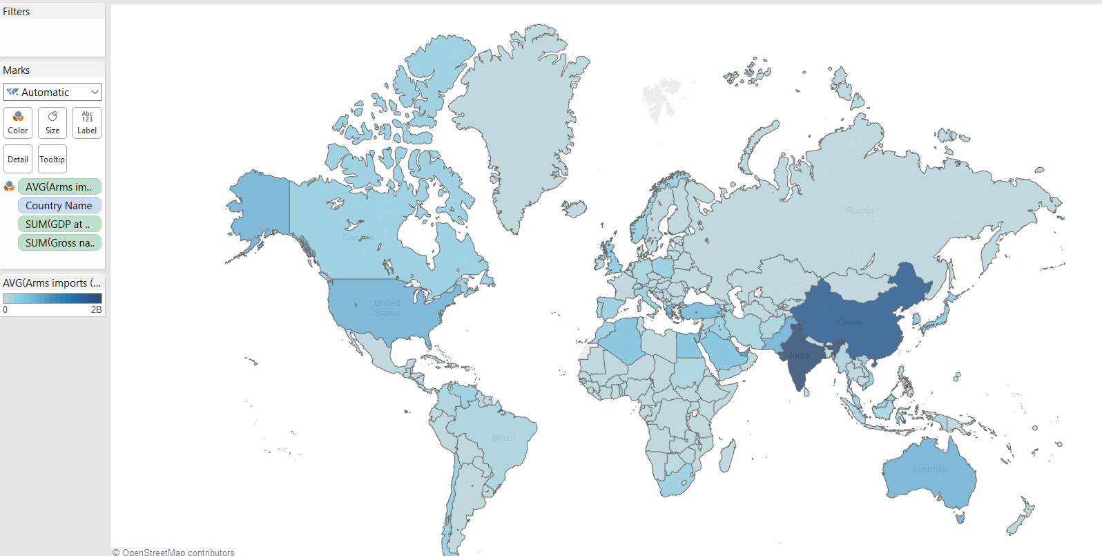

## Fitness of data

After accumulating the data at one place, I performed some data clean up and arranged the data in the following format.

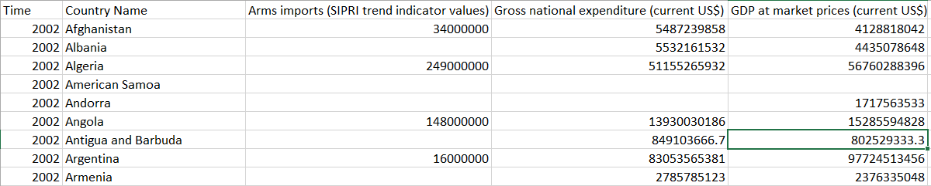

This gave me a clear idea on the dimensions and measures of my data.

I would like to elaborate on the graphs I have chosen to display and what they indicate.

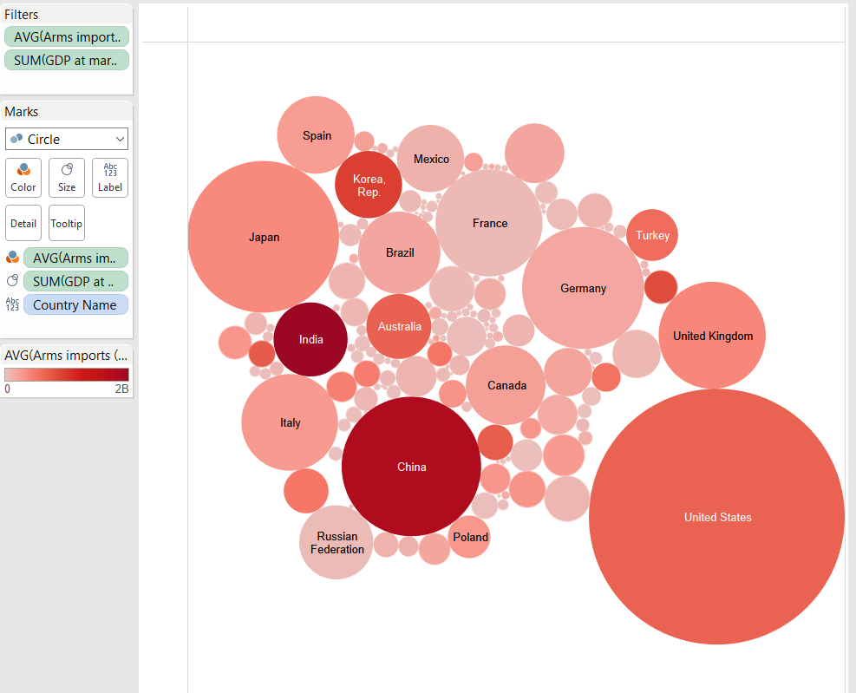

The size of the bubbles indicate the GDP of the countries, bigger the bubble, greater the GDP. The shade of Red indicates the value of arms imported.

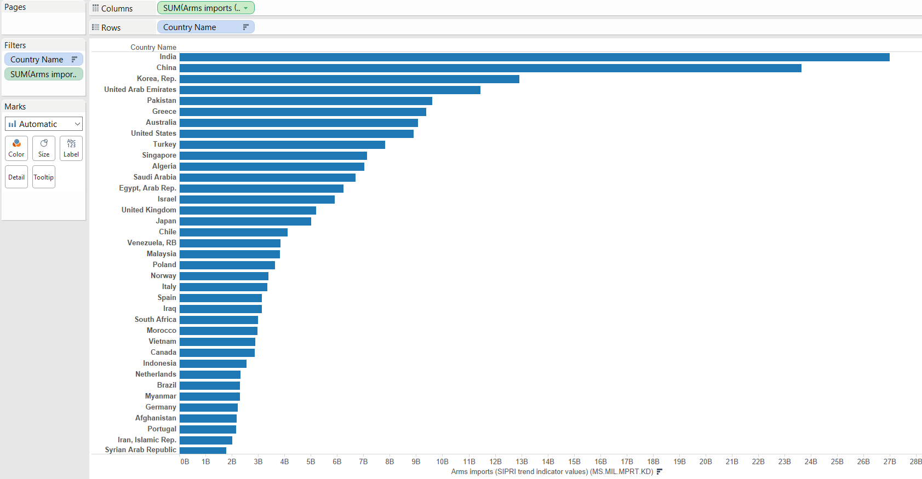

This snippet of the entire graph gives us the amount of arms imports by country. As we can see, India, China, Korea Rep., UAE & Pakistan are the countries with the highest amount of arms imported.

This next graph summarizes the data I exactly want to display. The countries who have the highest ratio of arms expenditure/total expenditure are the countries who do not have very high GDP’s. As the GDP of the countries increases, ratio of expenditure of arms to total expenditure decreases. Countries with lower GDP’s spend a lot more on arms that those with higher GDP’s. In this graph, the size of the circle represents the GDP of the country.

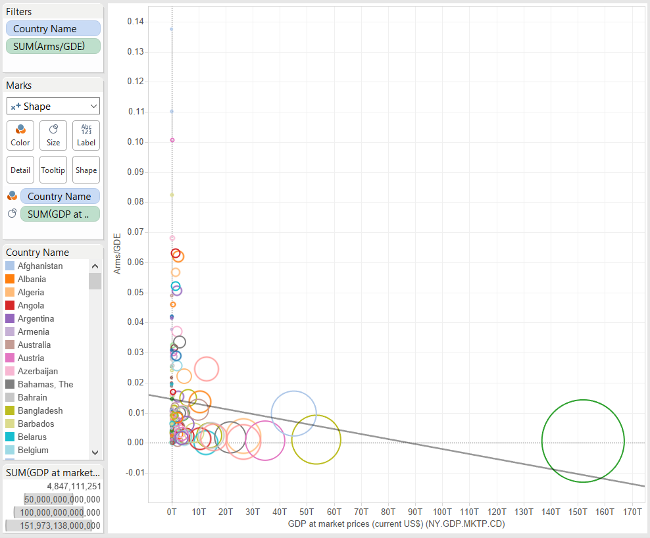

This fact is further elaborated in this next graph. A snippet is provided here, the complete graph is available at my tableau link.

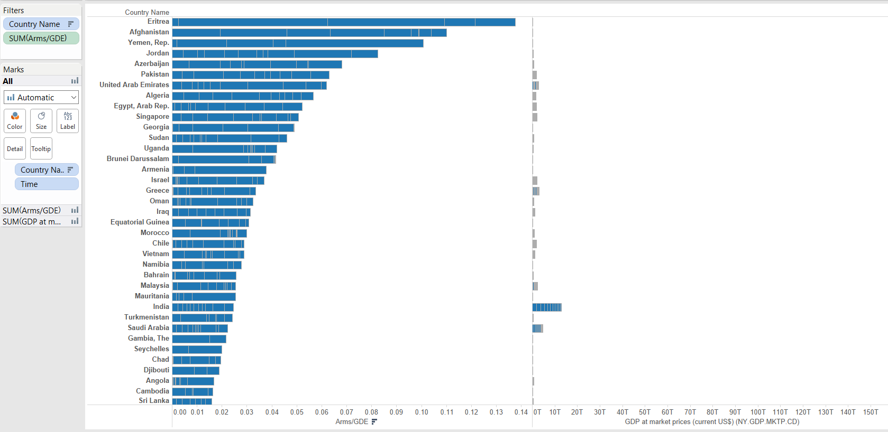

I have also included a box and whisker plot to represent the average spending of countries year wise. The color in this graph represents the GDP of the respective countries. As we can see, the countries in the high range of this graph have lighter color’s indicating lower GDP’s.

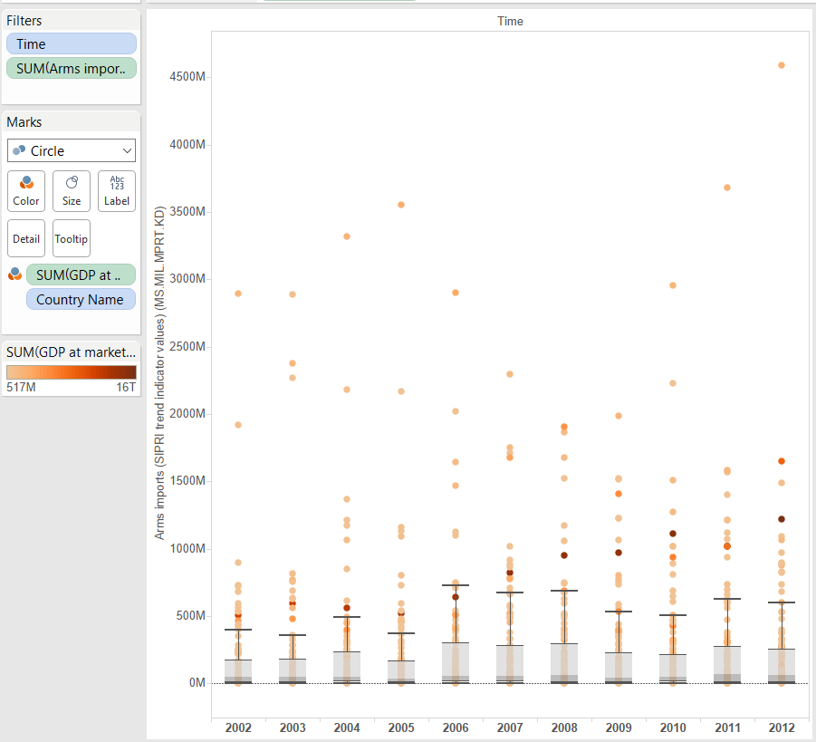

The fact I want to elaborate using these graphs is that the countries with lower GDP’s end up spending a very high amount in importing arms. We as a people face many more challenges in today’s age. Poverty, sickness, education, medicine are requirements of a higher priority. Not denying the fact that military needs are of importance, however I feel improving the internal factors of a country are more important than strengthening our militia.

My full story is present [here](https://public.tableau.com/profile/anurag.banerjee#!/).